Training manual: Jostra pump

NOTE Before use read the User Manual thoroughly!
(This section of the training manual is only a summary of parts of the vendor provided manual that may be needed for quick reference)

Pump modules
The complete system can run up to 1.5 hours on the battery backup.

Console modules
Air bubbles in a tube can be detected and prevented from entering the
patient.
Four temperature channels can be monitored
Four pressure channels can be monitored and (gently) regulated.
Digital and analogue communication with external devices is possible.

System control panel
Most functions needed during an operation can be controlled from the
system control panel.
System monitor unit
Useful signals and data are displayed.
A complete perfusion protocol can be recorded on-line or off-line with
JOCAP XL for later analysis and print-out.

The batteries are automatically charged when the machine is connected to the mains supply and the main switch is on. Therfore, this is the way the machine should be stored when not in use.
C A R D I O P U L M O N A RY
2.1 Front view of the console
1. Main switch of the whole system
Lit during mains operation. Switch off when not using the HL 20. Unplugging
from the mains only activates battery operation.
2. Monitoring system switch
Lit when the monitoring system is on.
3. Battery operation light
Lit during battery operation.
4. Battery charging light
Lit when the batteries are being charged. Not lit when the batteries are fully
charged.
5. Pump switches
Lit when the corresponding pump is on. This switch must be off before the pump is removed from the console. Otherwise it may register as a power surge and permanently break the protective device rendering unworkable until being serviced by a maintenance person.
6. Halogen lamp switch (MPL and MPR)
7. Halogen lamp
8. Halogen lamp switch (except MPL and MPR)
9. System control panel
10. Drawer
For hand cranks and other accessories. Can be opened from front
2.2 Rear view of the console

2. Quadruple distributor socket
Connect the mains plug (IEC cable) of the external device. See “1.4.4 External
devices”
2.3.2 Rear panels
2-pump console
Inside the module box Under the transparent flap

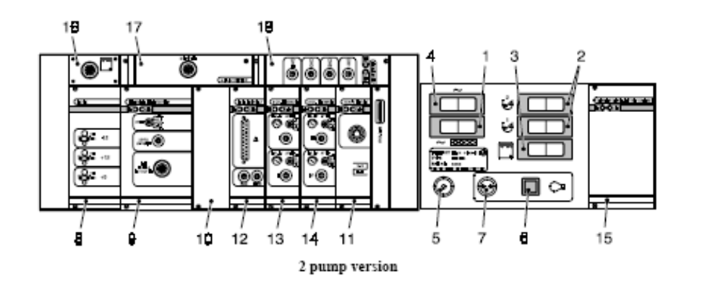

1. Circuit-breaker for the distributor socket
2. Circuit-breakers for the pumps
3. Circuit-breaker for the monitoring system
4. Main circuit-breaker
5. Connection for potential equalization
6. Circuit-breaker for the 24 V socket
7. Socket for an additional halogen lamp (24 V)
8. Power supply module
9. Air emboli protection module (or Air protection module, for bubble
sensor only or for level sensor only)
10. Blank
11. Quad temperature module
12. Analog in/out module
13. Dual pressure module, channel 1+2
14. Dual pressure module, channel 3+4
15. Console control module and battery charger module
Monitors different console functions, e.g. the battery charge, the pump fuses and
the supply voltages.
16. System control panel socket
The system control panel is usually always connected to the socket via an internal
cable.
17. Monitor interface module
2-pump console: The system monitor unit is usually always connected to the socket
via an internal cable.
18. Digital in/out module
19. Sockets for the Electronic Gas Blender EGB 20-250 and to remotely
control the Jostra Heater-Cooler Unit HCU 20
See also “1.6.2 Heater-Cooler Unit HCU 20”.
For a detailed description of individual modules, see separate chapter.
NOTE Do not use the circuit-breakers as on/off switches. They break the
circuit in case of error.

2.4 Working position
2-pump console
1. Loosen the lock screws for the
system monitor unit and the
system control panel.
2. Turn them into the desired
positions and tighten the lock
screws.
3. Draw back the locking knob
(black arrow) and turn the system
control panel into the desired
angle (white arrow).
4. Draw back the other locking knob
(black arrow) and swing the system
control panel upwards (white arrow)
until the locking knob latches again.
5. Turn the locking device to lock
the angle of the system control
panel.
6. Pull down the writing board.
2.7 Power supply
2.7.1 On the system control panel
1. Voltage display
Shows the percentage of the nominal voltage during mains operation. Flashes the
battery voltage during battery operation.
2. Battery voltage button
Press to see the battery voltage during mains operation.
3. Mains and battery LEDs
Indicates the mode of operation.
4. Audio off button
2.7.2 Battery operation
WARNING Let Jostra authorized personnel replace the batteries every two years
or when they can no longer be fully charged within 15 hours or when
fully charged batteries cannot run the complete system longer than
60 minutes. Check the battery capacity at least every six months.
Proper disposal of the batteries are ensured by handing them back to
Jostra.
The system automatically switches to battery operation when the mains
voltage is interrupted or falls below 85 % (±5 %). If power returns the
system automatically switches back to mains supply.
The batteries are automatically charged when the machine is connected to the mains supply and the main switch is on.
Battery voltage during battery operation
1. Normal operation time
• 27.4 V (fully charged battery) 􀃎 22.0 V
• Lit battery operation light on the console.
• The acoustic alarm can be switched off with the “Audio off” button.
2. Residual operation time
• 22.0 V 􀃎 19.3 V
• Flashing battery operation light on the console.
• The acoustic alarm (double beeps) cannot be switched off.
3. The system switches off!!
• 19.2 V
• Continuous beep alarm.
WARNING
When the voltage has sunk to 22 V (residual operation time) there is
only power for a few more minutes of operation.

3. Pump modules
NOTE Let Jostra or Jostra authorized personnel service the pumps every
6 months or 500 operating hours.
It is the responsibility of the operator to ensure that the servicing is
performed.
3.3 Front view
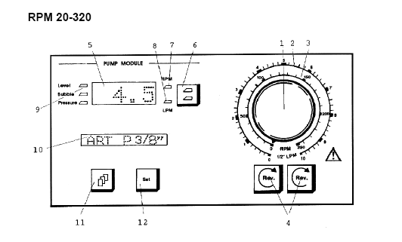
1. Flow adjustment knob
2. Flow scale
NOTE The flow scale of the RPM 20-320 is estimated for 1/2" tubes and of
the TPM 20-330 for 1/4" tubes (if the flow display stops working).
3. Speed scale (if the speed display stops working)
4. Reverse buttons
Lit when pumping in the reverse direction. See “3.7 Reverse pumping”.
5. Speed, flow or error messages (alphanumeric display)
6. RPM/LPM button
Press to switch the display between RPM and LPM.
7. RPM LED
Lit when the display shows RPM.
8. LPM LED
Lit when the display shows LPM.
9. Monitoring module intervention LEDs
See “3.13.3 Intervention of the monitoring modules”.
10. Status (alphanumeric display)
See “3.5 Modes of operation”.
11. Select button
12. Set button
13. Safety button (only TPM 20-330)
1. Flow adjustment screw
See “3.4.4 Flow display calibration”.
3.4.1 Insetting of inserts (RPM 20-320)
1. Pull the lever upwards to open the tube lock.
2. Twist the upper insert into the matching slot.
3. Lift up the bottom saddle and twist the bottom insert into the
matching slot. Put back the saddle.
A ball-spring mechanism in the saddle holds the insert in the correct
position.

3.4.3 Occlusion setting
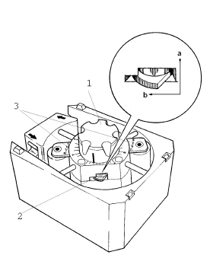
Set the occlusion before every use:
Alternative 1
1. Clamp the arterial tubing from the pump and monitor the pressure in
front of the clamp.
2. Adjust the occlusion so that the pressure stays between 240 and
300 mmHg when the pump runs at 5 RPM.
3. Calibrate the flow display (see “3.4.4 Flow display calibration”).
Alternative 2
1. Switch off the pump.
2. Unlock the occlusion lock.
3. Turn the occlusion adjustment knob until both rollers are tight against
the tube.
4. Lift one end of the tube and turn the pump head by hand to fill the
tube to a height of 1 metre above the pump head.
5. Turn the pump head so that only one roller is pressed against the
tube.
6. Release the occlusion until the level in the tube sinks by 2–3 cm per
minute.
7. Lock the occlusion lock.
8. Repeat the procedure with the other roller to check the occlusion.
9. Calibrate the flow display (see “3.4.4 Flow display calibration”).

3.4.4 Flow display calibration
After changing the tube the flow display must be calibrated.
Equipment
• Tube (ca. 1.5 metre)
• Water container (e.g. a 5 litre bucket)
• Measuring cylinder
• Stopwatch
• Adjustment screwdriver
NOTE Do not change the pump speed during measurement and calibration.
Preparation
1. Insert the tube and set the occlusion (e.g. as described above).
2. Select the tube size, see “3.6 Selection of settings”.
3. Prime the tube.
4. Place the measuring cylinder next to the water container.
Calibration
5. Press the “Select” button repeatedly until the status display shows
“CAL MODE”.
6. Press the “Set” button for three seconds. An acoustic signal sounds
and the status display flashes.
7. Set the pump speed so that the speed display shows a steady 60 RPM
for 1/2" tubes and 100 RPM for smaller tubes.
8. Move the outlet end of the tube to the measuring cylinder and start
timing simultaneously (use a stopwatch or timer III on the system
control panel).
9. Move the outlet end back to the water container after exactly one
minute, with the pump still running.
10. Measure the volume in the measuring cylinder.
11. Switch the display of the pump to LPM.
12. Adjust the display value to the measured volume by turning the flow
adjustment screw with an adjustment screwdriver.
13. Press the “Set” button for three seconds (press any other button to
leave the calibration mode without memorizing the adjusted flow
value). An acoustic signal sounds and the status display shows the
mode of operation together with the selected tube size.
14. Turn the flow adjustment knob to zero and empty the measuring
cylinder into the water container.
Checking the Calibration
15. Follow points 7 to 10 above.
16. Compare the volume in the measuring cylinder with the adjusted flow
value. If the difference is greater than permitted repeat points 5 to 16.

3.5 Modes of operation
Each pump must have a name describing its mode of operation. To select
the mode of operation, see “3.6 Selection of settings”.
Pump functions are controlled and data are recorded and displayed by
pump name. The allocation of names also makes it easy to use the
JOCAP software to analyse and graphically display all the flow values of
the different pumps.
NOTE A name selected for one pump cannot then be given to another pump,
except the “FREE” mode. The pump keeps its name until you assign
it a new name.
A pump keeps its assigned name when it is moved to a different
location on the console.
If a new pump, with a name that is already in use by a switched on
pump, is installed on a console it automatically becomes a “FREE”
pump when it is switched on.
There can be only one arterial pump (“ART” or “ART PULS”) and
only one slave pump (“SLAVE 1” or “SLAVE 2”).
The “FREE” pump cannot be influenced by external signals (e.g. the
monitoring modules).
Name in the “SET MODE” menu
Name in the status display during operation
ART ART
Arterial pump for continuous pumping.
ART PULS A-P
Arterial pump with a pulsatile pumping option (see “3.9 Pulsatile
pumping”).
FREE FRE
Pump detached from communication with the rest of the system.
Example: An error in the monitoring system might stop the pumps
(except the “FREE” pumps). Assign these pumps as “FREE” to continue
operation.

3.6 Selection of settings
1. Turn the flow adjustment knob to zero.
2. Press the “Select” button repeatedly until the status display shows
what you want to change of the following:

“SET MODE” – Mode of operation
3. Press the “Set” button.
4. Press the “Select” button to choose the desired mode of
operation.

“SET TUBE” – Tube size
3. Press the “Set” button.
4. Press the “Select” button to choose between the tube sizes 1/4",
3/8", 1/2" and special (TPM 20-330: 1/4" and special). (For the
tube size “spec”, intended for cardioplegia operation, the pump
can be calibrated to a scope of 2.8 to 5.1 LPM (TPM 20-330:
0.21 to 1.52 LPM) at maximum speed.)
“CAL MODE” – Flow display calibration
See “3.4.4 Flow display calibration”.
“SET BRIG” – Display brightness
3. Press the “Set” button.
4. Press the “Select” button to choose between 25 %, 50 % and
100 % brightness.
“SET S-AL” – Soft alarm
(this needs to be on in order to have the pump servoregulate !
See “4.2.5 Operation” and “4.3.5 Delay”.
3. Press the “Set” button.
4. Press the “Select” button to choose between soft alarm on and
soft alarm off.
5. Press the “Set” button for three seconds (press any other button to
leave the selection of settings without memorizing the change). An
acoustic signal sounds and the status display shows the mode of
operation together with the selected tube size.
For “SET RAT this is for cardioplegia
NOTE The flow adjustment knob must be turned to zero to select settings.
Each tube size must be calibrated, see “3.4.4 Flow display
calibration”.

3.7 Reverse pumping
WARNING Reverse pumping could suck air into the blood circulation, which
could cause death or severe injury to the patient. Reverse pumping
should only occur in exceptional cases.
The pump returns to normal pumping direction, marked by the
arrows on the pump head, after a “cold-start”.
1. Turn the flow adjustment knob to zero.
2. RPM 20-320: Press both “Reverse” buttons simultaneously for three
seconds.
TPM 20-330: Press the “Reverse” button of the corresponding pump
and the “Safety” button simultaneously for three seconds.
3. An acoustic signal sounds.
4. Turn the flow adjustment knob to the desired flow.

3.11 Installing a pump
1. Switch off the pump switch on the console.
2. Remove the socket cover on the console.
3. Put the pump carefully in place. The pump is immediately ready for
operation.
3.12 Removing a pump
1. Switch off the pump switch on the console.
2. Lift off the pump.
3. Put on the socket cover on the console.
CAUTION
Only use the pump module on a Jostra console.

Switch off the pump switch on the console before installing or
removing a pump. (Failure to do this can damage the pump so it does not function until being repaired by a maintenance person)

Put on the socket covers on vacant pump sockets on the console to
protect them from liquids.
Never put a pump on an uneven surface as this could damage the
plug.
3.13 Safety
The pump must switch to a safe state, a stop (as this could be managed
through manual operation), at defects which could lead to faulty
operation of the pump.
The pump is continuously monitored during operation. If an error is
found, the pump stops and a display message is shown (see “3.13.6 Error
messages”).
3.13.1 Messages when switching on
Speed/flow
display
Status display Meaning
1. 􀂄􀂄􀂄􀂄􀂄􀂄􀂄􀂄 􀂄􀂄􀂄􀂄􀂄􀂄􀂄􀂄 Lamp test: all display points and all LEDs are lit
and the acoustic alarm beeps.
2. E2.2 HOUR XXX E2.2: Present software version (E = English).
XXX: Operating hours of the pump since the
last service.
3. –OK– PUMP OK Self-test concluded without errors.
When the pump is switched on it performs a self-test. If an error is found,
the pump cannot be started and a message is shown in the status display
(see “3.13.6 Error messages”).

3.13.2 Before operation
• Check that the pump functions both forwards and backwards.
• Check that the correct mode of operation is assigned for the pump.
• Check that the correct tube size has been selected.
• Check that the speed display corresponds to the speed scale at the
flow adjustment knob.
• Check the intervention of the monitoring modules by simulating an
alarm condition for the chosen interventions.

3.13.3 Intervention of the monitoring modules
An optional pump (except a “FREE” pump) can be set not to exceed a
pressure limit or to stop at the detection of air bubbles in a tubing or a
low liquid level in a reservoir. See “4. Console modules”.
The chosen intervention for a pump is shown by the LEDs on the front
panel.
NOTE If the intervention is switched off, or at module failure, the
corresponding LED starts to flash. Switch off the pump for a few
seconds to cancel the flashing.
The status display shows if a monitoring module has stopped the pump:
STOP -- Pump stopped by external (not yet identified) module.
This might occur when there are communication errors, if
the monitoring system has been switched off or
immediately after reprogramming a pump.
STOP PRx Pump stopped by the monitoring of pressure x (x = 1 to 4).
STOP BUB Pump stopped by the air bubble monitoring.

3.13.4 Switched off monitoring system
The pumps stop (except the “FREE” pumps) if the monitoring system is
switched off. An acoustic alarm sounds and the display flashes “NO
COMM”. The intervention LED flashes on pumps with a chosen
intervention.
To continue operation, the pumps can be assigned as “FREE” as
described in “3.5 Modes of operation” and “3.6 Selection of settings”.
Here is a simpler method:
1. Turn the flow adjustment knob to zero (the acoustic alarm is switched
off).
2. The display flashes “SET FREE”. Press the “Set” button to switch the
pump to the mode of operation “FREE”.
3. Turn the flow adjustment knob to the desired flow.
WARNING The pumps which have been switched to “FREE” remain as “FREE”
when the monitoring system is switched on again.
Intervention of the monitoring modules does not work in the mode of
operation “FREE”
.
3.13.5 Manual operation
A pump is easily replaced with a spare pump (see “3.11 Installing a
pump” and “3.12 Removing a pump”). In an emergency, the pump can be
operated manually.
WARNING
Keep the hand crank available in case of an emergency.
Pump in the direction of the arrows on the pump house.
Reverse pumping could suck air into the blood circulation, which
could cause death or severe injury to the patient. Reverse pumping
should only occur in exceptional cases.
RPM 20-320
TPM 20-330
1. Switch off the pump.
2. Open the pump head cover.
3. RPM 20-320: Insert the hand crank into the hand crank hole on the
pump.
TPM 20-330: Raise the handle of the hand crank. Put the hand crank
on the occlusion adjustment knob on the pump.
4. Turn in the direction of the arrows.

3.13.6 Error messages
Speed/flow display
Acoustic alarm (Y = Yes, N = No)
Pump stop (Y = Yes, N = No)
Message Error source
ERR. – – Error: The status display shows a further message.
RUNAWAY Y Y The pump runs more than 10 % faster than the set value (at
continuous pumping). The reaction time is about 1 second.
At pulsatile pumping, the reaction time is about 1.5 seconds.
Turn the flow adjustment knob to zero to reset the error.
!!!! Y Y More than one “RUNAWAY” within 5 seconds. Switch off the
pump to reset the error.
↑↑↑↑ N N Slightly too high flow at pulsatile pumping, indicated after about
5 pulse beats.
<=<= Suggestion to turn the flow adjustment knob to zero.
NO COMM Y Y Error in the communication with the rest of the system. See
“3.13.4 Switched off monitoring system”.
User Manual Art.no. 931451 C.o. J1904 3-37
Pump modules Heart Lung Machine HL 20
Status display
Acoustic alarm (Y = Yes, N = No)
Pump stop (Y = Yes, N = No)
Message Error source
OVERLOAD – – The pump runs more than 10 % slower than the set value. Check
the insertion of the tube and the occlusion setting.
BELTSLIP N N The pump runs more than 10 % slower than the pump motor.
More “beltslip” leads to the “HEAD” error.
OV.SPEED N N Slave pump speed above 250 RPM.
KEYSTUCK Y N A button has been depressed for longer than 15 seconds.
SET SIZE N N The tube size has not been set.
HI- TEMP N N The temperature of the electronics (motor) is above 60°C
(70°C).
TEMP. Y Y The temperature of the electronics (motor) is above 70°C
(90°C). The pump cannot be started until the temperature has
gone down.
SAFETY-S Y Y Safety system.
DIRECT. Y Y The pump is turning in the wrong direction. The reaction time is
1/4 revolution.
HEAD Y Y Tachometer. The acoustic alarm sounds and the pump stops.
NOTE If the temperature of the electronics (motor) is above 45°C (60°C),
the ventilator switches to full speed.
The pump shouldn’t run so hot in normal operation that a display
message is shown. If this happens, check the insertion of the tube and
the occlusion setting.

3.13.7 Runaway protection diagram
A safety system stops the pump, if it (in case of error) is running too fast.

Flow, 3/8" tubes
Flow rate 0 to 6.60 LPM
Display resolution 0.10 LPM
Display accuracy ±0.10 LPM
Flow, 1/4" tubes
Flow rate 0 to 3.20 LPM
Display resolution 0.01 LPM
Display accuracy ±0.01 LPM

4. Console modules
Air bubbles in a tube can be detected and prevented from entering the
patient.
A too low liquid (blood) level in a reservoir can be detected and (gently)
regulated.
Four temperature channels can be monitored
Four pressure channels can be monitored and (gently) regulated. Suction
can be controlled.
Digital and analogue communication with external devices is possible.
See also “2.3 Rear panels of the console”.

4.1 Air bubble detector
NOTE Must be run in the horizontal position.
Alarms if run with the tubing in a vertical position.
WARNING Always prime the tubing completely and free of air.
The bubble detector is an additional safety measure, use also a
bubble filter in the arterial line.
Use only a fully functioning air bubble detection system during an
operation. Perform a complete function test before every use.
After a bubble intervention, remove the bubbles from the
extracorporal circulation before starting the pump again.
A pump chosen for bubble intervention is immediately stopped when
there are too many bubbles with a diameter between 1 mm and 5 mm or
one bubble bigger than 5 mm.
All common sizes of PVC and silicone tubes can be used, just change the
tube inserts.
It is possible to work without ultrasonic gel, at e.g. long-term perfusions
(ECMO etc.).
4.1.2 On the system control panel
1. Bar LEDs
Single bar lit for micro bubbles from a diameter of about 300 μm to 1 mm.
Continuous row of bars lit for bigger bubbles. The further to the right, the more or
the bigger the bubbles.
2. Air bubble alarm
Lit (red) when the pump is stopped due to too many bubbles with a diameter
between 1 mm and 5 mm or one bubble bigger than 5 mm.
3. Sensor fault alarm
Lit (red) when no sensor is connected or at sensor faults. The pump chosen for air
bubble intervention is also stopped and an acoustic alarm sounds.
4. Reset button
Press together with the “Safety” (dogear) button to reset the air bubble detector after a pump
stop. Must push twice, or push and hold.
5. Override button
Press together with the “Safety” button to override air bubble alarms (the pump
will not be stopped). Flashes red when activated.

4.1.3 Function test
1. Put a tube sample containing an air bubble into the sensor (with the
right tube inserts).
2. Turn the sensor so that the bubble in the tube sample floats above the
sensor.
3. Run the pump chosen for air bubble intervention.
4. Turn the sensor so that the bubble passes the sensor.
5. Check that the pump stops, the acoustic alarm sounds and the air
bubble alarm lights up.
4.1.4 Preparation for operation
1. Inset the correct size inserts for the tube to be used.
2. Put some ultrasonic gel on both sides of the sensor between the tube
and the white contact cushions.
3. Apply the sensor as horizontally as possible to the tube on a suitable
place on the extracorporal circulation. Press the two halves firmly
together.
NOTE Ultrasonic gel is recommended although the sensor is intended for
use without it. Gel increases the sensitivity.
4. Connect the sensor to the air bubble sensor socket and turn the
intervention switch to the desired pump.
5. Fill the tube.
6. Switch on the monitoring system.
7. A self-test is run. If an error is found the pump stays stopped and the
sensor fault alarm lights up.
8. An automatic adjustment to the tube is performed. This can take
some seconds (faster with thinner tube wall and with silicone tubes).
(This is indicated by continuous rows of bars moving towards each
other on the bar LEDs.)
9. If the adjustment is unsuccessful (the continuous rows of bars stay
separated), the pump stays stopped. Check the fit of the tube and that
the silicone cushions in the sensor are clean. If this is unsuccessful try
some more gel.
10. The pump is released after a successful adjustment.
User Manual Art.no. 931451 C.o. J1904 4-5

Console modules Heart Lung Machine HL 20
4.1.5 After operation
• Rinse with tepid water to remove the gel from the sensor and the
silicone cushions.
• Check that the silicone cushions in the tube inserts are not damaged
as this could impair the sensitivity especially for micro bubbles.
4.1.6 Technical data
Sensitivity to air bubble diameter
Immediate pump stop > 5 mm (0.065 cm3)
Registered bubbles > 300 μm

4.3 Pressure modules
WARNING Use only fully functioning pressure limitation equipment during an
operation. Perform a complete function test before every use.
Set the pump flow so that the patient will not be harmed even if the
pressure limitation ceases to function.
4.3.2 On the system control panel
1. Pressure (alphanumeric display)
Displays pressures between +997 mmHg and –997 mmHg.
2. Trend LEDs for the pressure
3. Pressure difference between channel I and II (alphanumeric display)
4. Trend LEDs for the pressure difference
5. mmHg / kPa button
Press to switch the display of the pressure on channel I and II and the pressure
difference between mmHg and kPa. Lit when showing kPa.
6. Trend button
Press to see the channel I and II pressure trends and the pressure difference trend in
mmHg/min or kPa/min.
7. Trend button
Press to see the channel III and IV pressure trends in mmHg/min or kPa/min.
8. mmHg / kPa button
Press to switch the display of the pressure on channel III and IV between mmHg
and kPa. Lit when showing kPa.
9. Override button
Press together with the “Safety” button to override pressure alarms (the pump will
not be stopped). Flashes red when activated.
10. Pressure limit button
Press to see the upper limit (flashing “HL:”) every other time and the lower limit (flashing “LL:”) every other time. Hold down this button and turn the adjustment knob to set the limit. At 0 or –1, hold down this button and press the “Safety”
button to switch between the positive and the negative range.
NOTE At a positive upper limit or a negative lower limit, the pump stops
and the acoustic alarm sounds.
At a positive lower limit or a negative upper limit, the acoustic alarm
sounds but the pump does not stop.
11. Zero alignment button
12. Amplitude button

4.3.3 Pressure transducer calibration
See manual if it seems to need calibration. Step by step instructions can be found there.
4.3.4 Function test
1. Set a positive upper limit.
2. Run the pump chosen for pressure intervention.
3. Press the tube together beyond (in the flow direction) the measuring
point, so that the pressure exceeds the pressure limit.
4. Check that the pump stops, the acoustic alarm sounds, the pressure
display flashes and the status display of the pump shows “STOP
PRx” (x = 1 to 4, for the pressure channel being used).
NOTE Check all the events in point 4 to make sure that both the transducer
and the module work.
4.3.5 Delay
At a positive upper limit and a negative lower limit, the pump chosen for
pressure intervention stops gradually when the pressure limit is exceeded
and starts gradually when the limit is no longer exceeded. The speed
stays reduced when the pressure is less than 10 % (or less than 10
mmHg) within the pressure limit (the status display of the pump flashes
“STOP PRx” and the soft alarm sounds, if chosen (see “3.6 Selection of
settings”)).
Turn the delay screw on the pressure module to choose how fast the
pump should stop and start at the pressure limit. The further it is turned
to the right, the more gradual the speed change. This gentle regulation
prevents oscillations.

4.3.6 Operation
Pressure measuring only
Set pressure limits which will not be reached during normal operation.
Pressure limitation and/or alarm
Set the desired pressure limits at which the pump will be stopped and/or
the acoustic alarm will sound.
A negative lower limit can be used for controlled suction. The pump will
be stopped at a more negative pressure (harder suction) than the set
value.
4.3.7 Display messages
─ S S ─ Pressure module missing or defect.
─ ─ ─ ─ Pressure transducer not connected.
↑ Pressure above 997 mmHg (132.9 kPa).
↓ Pressure below –997 mmHg (–132.9 kPa).
CAL Pressure module performing self-calibration.
ERxx Error (xx = error code).
The display flashes and an acoustic alarm sounds when a limit value is
exceeded.

4.4 Quad temperature module
NOTE Use insulated thermistor temperature probes of the YSI 400 series by
Yellow Springs or other compatible probes.
4.4.3 On the system control panel
1. Temperature display, channel I
(correspondingly for channel II–IV)
2. Trend LEDs for the temperature, channel I
(correspondingly for channel II–IV)
3. Trend button
Press to see the temperature trends in ºC/min.
4. Channel selector button
Press to select the channel for which a temperature limit is to be set.
5. Channel selector LEDs
Indicates the selected channel.
6. Upper temperature limit button
Press to see the set limit. Hold down this button and turn the adjustment knob to set
the limit.
7. Lower temperature limit button
Press to see the set limit. Hold down this button and turn the adjustment knob to set
the limit.
8. Selection LEDs
Indicates the selected temperature channel that can be used to control the Jostra
Heater-Cooler Unit HCU 20. See Heater-Cooler Unit HCU 20 User Manual,
“3.3 Operation with the HL 20”.
4-22 Art.no. 931451 C.o. J1904 User Manual
Heart Lung Machine HL 20 Console modules
4.4.4 Display messages
─ S S ─ Temperature module missing or defect.
─ ─ ─ ─ Temperature probe not connected.
↑ Temperature above 50.0°C.
↓ Temperature below 0°C.
ERxx Error (xx = error code).
The display flashes and an acoustic alarm sounds when a limit value is
exceeded.
1 After a sudden temperature change the electronics need about
60 seconds to calculate a new trend.

4.5 Power supply module
The power supply module supplies the whole monitoring system with
necessary operational voltages.
WARNING Adjustment of the operational voltages must be made at Jostra
servicing. Wrongly set voltages may result in errors.
4.5.1 Module panel
The functions for –12 V pointed out in the figure work correspondingly
for +12 V and +5 V.
1. Voltage adjustment screw
2. Voltage test socket
3. Ready LED
Lit when the voltage is on.
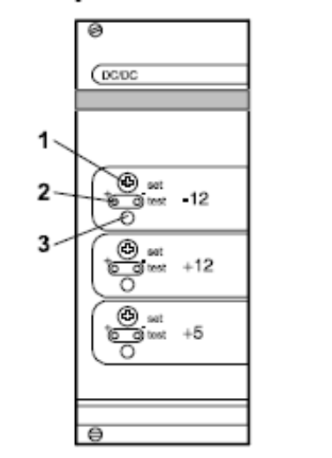
Console modules Heart Lung Machine HL 20
4.6 Analog in/out module
WARNING
External devices must comply with the instructions in “1.4.4 External
devices”.

4.6.1 Module panel
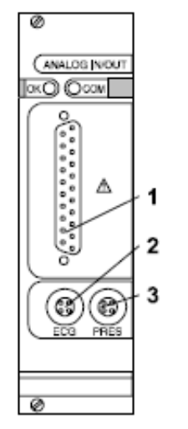
1. Signal socket (D-sub)
2. External ECG signal socket
3. External pressure signal socket

4.6.2 Socket pins
1 ECG curve input
2 Pressure curve input
3 Systolic pressure input
4 Diastolic pressure input
5 Mean pressure input
6 Free input
7 Free input
8 Free input
9 Circuit ground
10 Not connected
11 Not connected
12 Not connected
13 Not connected
14 Pressure 1 curve output
15 Pressure 2 curve output
16 Pressure 1 average output
17 Pressure 2 average output
18 Temperature 1 output
19 Temperature 2 output
20 Temperature 3 output
21 Temperature 4 output
22 Arterial flow output
23 Free output
24 Circuit ground
25 Earth

4.6.3 Technical data
Input impedance (all entries) ca. 10 KΩ
Output impedance (all exits) ca. 1 KΩ
Input voltage for full-scale deflection
±0.25 V to ±2.5 V (internally
adjustable)
User Manual Art.no. 931451 C.o. J1904 4-27
Console modules Heart Lung Machine HL 20
4-28 Art.no. 931451 C.o. J1904 User Manual
4.7 Digital in/out module
WARNING
External devices must comply with the instructions in “1.4.4 External
devices”.
A perfusion data record is given every 15 seconds.
4.7.1 Module panel
1
1. Sockets, channel I–IV
4.7.2 Socket pins
1 ---
2 TXD (HL 20 output)
3 RXD (HL 20 output)
4 ---
5 GND
6 ---
7 RTS (HL 20 output – not used)
8 CTS (HL 20 input – not used)
9
4.7.3 Interface
• Serial RS232
• 9600 Baud
• 8 data Bits
• 2 stop Bits
• No parity
Heart Lung Machine HL 20 System control panel
5. System control panel
Most functions needed during an operation can be controlled from the
system control panel.
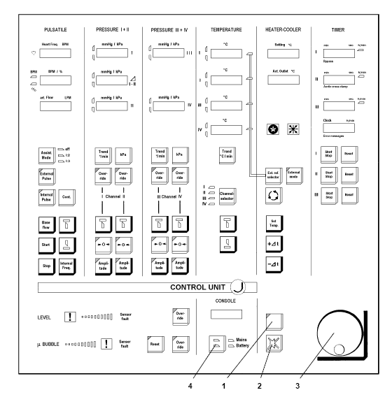
1. Safety button
2. Audio off button
Flashes when the present acoustic alarm is switched off. The acoustic alarm returns
with every new alarm condition.
3. Adjustment knob
4. Battery voltage button
NOTE Hold down the “Safety” button and press the “Battery voltage” button
to choose between 25 %, 50 % and 100 % display brightness.

5.1 Button types
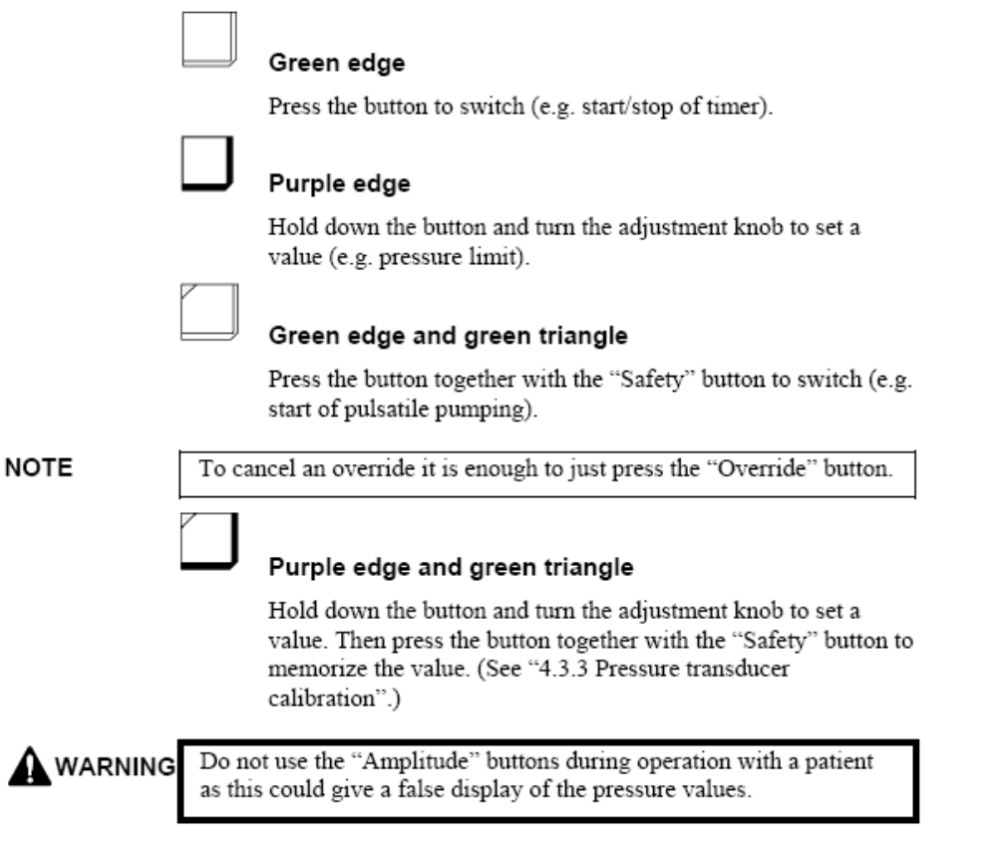
.
7. Clock
Press the “Safety” and the “Audio off” buttons simultaneously. Turn the adjustment
knob to set the hours. Press the “Safety” and the “Audio off” buttons
simultaneously. Turn the adjustment knob to set the minutes. Continue this way to
set in turn seconds, day of the week, month, day of the month and year.

5.3 Display and error messages
5.3.1 General messages
─ S S ─ Module missing or defect.
. Module not operating.
─ ─ ─ ─ Sensor not connected.
The display flashes and an acoustic alarm sounds when a limit value is
exceeded.
5.3.2 Error codes
Module errors are shown as “ERxx” (xx = error code; e.g. is “0A” a
display error and “14” a key stuck error) in the uppermost display of the
corresponding field. A system control panel error is shown as “EMxx” or
“EPxx” in the clock display of the timer field.
NOTE If an error message appears, see the Service Manual.
Use only a fully functioning system control panel during an
operation.
User Manual Art.no. 931451 C.o. J1904 5-5
System control panel Heart Lung Machine HL 20
5-6 Art.no. 931451 C.o. J1904 User Manual
5.3.3 Error EM7F
The last settings are saved (in an EEPROM) when the HL 20 is switched
off. These are read and used at the next start.
If these settings cannot be read the error message “EM7F” is shown.
Switch the monitoring system (not the whole system) off and on to
cancel the error. The settings are replaced by default settings (see below).
NOTE The last settings are saved when the whole system is switched off or
the mains plug is unplugged (or at power failure). These are not
necessarily saved when just the monitoring system is switched off.
5.3.4 Default settings
Pressure
Upper limit 200 mmHg
Lower limit –100 mmHg
Amplitude 1
Temperature
Upper limit 41°C
Lower limit 25°C
Pulsatile
Start 20 %
Stop 80 %
Baseflow 0 %
Internal frequency 72 BPM
Upper frequency alarm 120 BPM
Lower frequency alarm 40 BPM
Heart Lung Machine HL 20 System monitor unit
6. System monitor unit
Useful signals and data are displayed.
A complete perfusion protocol can be recorded on-line or off-line with
JOCAP XL for later analysis and print-out.

